Chapter 14, Problem 86.

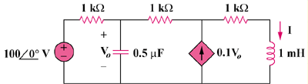
Using Fig. 14.103, design a problem to help other students to better understand how to use PSpice to obtain the frequency response (magnitude and phase of I) in electrical circuits.
V_{s}
R₁
R₃
R₂
C
L
kV_{o}

Figure 14.103
For Prob. 14.86.

